Leveraging Business Analytics for Audit and Fraud Detection: A Review of Digital Tools, Red-Flag Indicators and Practical Implications

Abstract: The growing complexity and digital evolution of financial systems have showed significant shortcomings in traditional auditing techniques particularly in identifying and mitigating intricate fraud schemes. This study tries to find how business analytics improves contemporary audit functions by enhancing fraud detection, increasing audit efficiency and facilitating predictive real-time assurance in different institutional contexts. A comprehensive qualitative evaluation technique was applied such as thematic synthesis, comparative analysis and typological classification to examine analytical tools, organizational readiness and sector-specific implementations derived from academia and industrial sources. Methods including anomaly detection, predictive modeling, clustering algorithms and machine learning are analyzed for their efficacy in detecting atypical financial transactions, behavioral irregularities and structural discrepancies. Case studies from corporate, public, and non-profit sectors show the advantages of analytics in enhancing real-time auditing and reducing fraud risk. The research also illustrates ongoing obstacles such as inconsistent data systems, deficiencies in auditor expertise and ethical concerns around algorithmic bias and insufficient transparency. Theoretically the research enhances audit literature by establishing business analytics as a dynamic accelerator for proactive auditing. It provides a strategy framework for auditors and organizations to improve digital audit capabilities, strengthen fraud prevention initiatives and guide governance and regulatory policies. The results provide significant insights for academics, professionals and policymakers dedicated to enhancing digital assurance in a more complex and data-centric financial landscape.

Keywords: Business Analytics, Audit Automation, Fraud Detection, Red-Flag Indicators, and Predictive and Prescriptive Analytics

- Introduction:
The fast change of financial systems has fundamentally improved the auditing by producing large quantities of accounting data that can not be done easily through traditional audit methods (Ebirim et al., 2024). Conventional auditing based on periodic review cycles, human judgment and selective sampling methods was created for a less complex time when financial records were fewer, more stable and less prone to intricate manipulation (Darwin, 2024). In modern organizations, manual audit methods generally scrutinize only a limited subset of transactions allowing pervasive fraud in extensive transaction populations to remain undetected for prolonged durations, frequently lasting months before resulting in significant financial loss (Rumasukun, 2024). These conventional steps possess natural limitations in detecting subtle and deliberately hidden replacements in financial papers. That’s why they do not provide the prompt assurance demanded by the swiftly changing business domain. As financial crimes become harder to identify because of digital weakness, complex vendor networks and digital payment systems, traditional audit methods are insufficient and have become a vital governance risk requiring effective action (Johnson-Rokosu & Enobi, 2025; Elumilade et al., 2024).
Business analytics (BA) has appeared as a solution to these structural constraints, signifying a major transition from reactive, periodic assurance to proactive, continuous and data-driven auditing practices (Nouri, 2024; Chowdhury et al., 2025). By facilitating the examination of complete transaction populations instead of samples BA empowers auditors to uncover anomalies, recognize behavioral oddities and demonstrate structural flaws in real time. Machine learning algorithms, predictive risk models, network analysis tools and natural language processing capabilities have collectively enhanced the auditor's detection capabilities, facilitating the identification of nuanced indicators such as irregular journal entry patterns, atypical vendor relationships and after-hours system access which often occur before or at the same time as with fraudulent activity (Darwish, 2024; Ilori et al., 2024; Panchapakesan et al., 2025). The visible outcomes are countable with organizations utilizing analytics-driven auditing reporting enhancements in fraud detection rates of 30 to 50 percent compared to conventional techniques and a reduction in false positive rates in anomaly detection due to machine learning optimization (Fernandes Jr. et al., 2019; Johnson-Rokosu & Enobi, 2025). Overall these trends indicate that the transition to analytics represents not only a technology enhancement but also a substantial advancement in audit efficacy and governance responsibility.

In spite of the rising amount of data, the existing research on BA in auditing remains ambiguous and insufficiently advanced in some critical dimensions. A major shortage of comparative research assessing the relative effectiveness of different analytical methods such as supervised and unsupervised machine learning, across numerous audit contexts and fraud types. The literature shows limited guidance on the practical use of business analytics in businesses particularly with change management, workflow integration and the development of hybrid talents that combine accounting proficiency with data science capabilities. In addition to most contemporary research adopts narrow perspectives, focusing on particular technologies, individual industrial case studies or technological performance metrics that are separate from the organizational and ethical challenges experienced during practical implementation (Sewpersadh, 2025). The result is a field in which professionals face legitimate uncertainty regarding the choice of tools, their incorporation into existing audit processes, the handling of concerns related to algorithmic bias and transparency and the enduring effects of analytics implementation on audit quality and professional skepticism. Without a comprehensive synthesis that integrates these different parts, academics and practitioners lack the structured foundation needed to advance analytics adoption responsibly and effectively.
Resolving these shortcomings has significant implications for different stakeholder groups which plays the role of the main motivation for our initiative. The absence of established implementation standards for audit professionals leads to inconsistent adoption strategies and undermines confidence in algorithmic outcomes. The lack of uniform standards for algorithmic auditing presents regulatory challenges as analytics increasingly integrate into global assurance practices. The gap between the existing curriculum and the hybrid skills required by auditors undermines graduates' readiness for data-driven practice (Akula & Garibay, 2021). Furthermore as stakeholder expectations change and regulatory oversight increases across sectors, strong analytical abilities are essential for keeping the relevance and value of audit operations (Usul & Alpay, 2025). The rarity of a connected theoretical framework for future researchers suggests that empirical studies in BA and auditing are conducted without a systematic structure, limiting comparability and the advancement of knowledge. This work acts as an essential connection between academic research and practical application, providing the evidence-based synthesis that these entities currently require.
This study aims to achieve four specific objectives. It systematically collects and analyses the analytical methodologies applied in audit practice including machine learning algorithms, process mining tools and visualization platforms, assessing their individual advantages and limitations. Secondly it establishes an evidence-based classifications of red-flag indications including financial errors, behavioral patterns and structural imbalances. This gives auditors a framework to checking major issues. Thirdly it analyses the diversity of BA implementation in the audit and industry sectors to identify sector-specific adoption patterns, challenges and success determinants. At last it outlines the technological, organizational and ethical barriers, such as deficiencies in data quality, lack of competence and issues of algorithmic transparency.
This study implements a qualitative integrative review approach to achieve its objectives analyzing 84 peer-reviewed articles, industry reports and professional publications from five major academic databases: Scopus, Web of Science, IEEE Xplore, SSRN, and Google Scholar, covering the years 2015 to 2025. An integrative method was applied because of the broad-range nature of the literature. The main findings show although business analytics (BA) possess clear and measurable advantages including population-level transaction testing, improved detection accuracy and real-time risk signaling, its effective application is considerably hindered by data quality deficiencies, recognized by 73% of organizations as the primary obstacle (Wolniak, 2024), skill gaps affecting 68% of audit teams (Vesty et al., 2023) and persistent ethical issues surrounding ai based insight and imbalance(Landers & Behrend, 2023). Adoption rates differ clearly across sectors particularly in the financial institutions show a rate of 87% primarily due to regulatory pressures while small and medium-sized enterprises report a mere 23%, mainly attributable to resource and capacity constraints (Kothandapani, 2025; Fiolleau et al., 2024). Forensic investigations are enhanced by network analysis skills (Hezam et al., 2023) and regulators are progressively adopting business analytics for systemic risk monitoring and compliance trend analysis (Syam et al., 2025).

This research provides several contributions to the domain of audit scholarship and practice. It develops a cohesive conceptual framework that amalgamates previously distinct research strands on business analytics in auditing, positioning analytics as a fundamental enabler of proactive, risk-orientated assurance rather than merely an ancillary instrument. It includes an evidence-based taxonomy of red-flag indicators and a systematic classification of implementation barriers.It also provides a reference for future research and a sector-specific model for organizations at different levels of technical capability. The study shows audit professionals with practical implementation strategies for key areas and assist software firms to design realistic analytical solutions. They also provide regulators and standard-setters with evidence to develop appropriate frameworks for digital auditing. Educational institutions are also associated because the literature shows the need for enhancing the quality of accounting and audit education. This includes projects that combine data science skills with traditional audit training.

- Methodology:
This study provides a structured qualitative approach to evaluate the impact of business analytics on auditing and fraud detection. It enables the facilitation of the systematic identification and evaluation of digital technologies, auditing procedures and fraud indications. The process implements comparative and thematic analysis so that it can integrate theoretical insights with practical evidence. Considering the transdisciplinary and intellectual nature of the research challenge, this study adopts an integrative review technique instead of a simple systematic review which is emphasizing synthesis rather than data pooling. To improve transparency and rigor, a PRISMA-based screening structure was applied while selecting the literature.
2.1. Research Design, Philosophical Orientation and Analytical Strategy
The current research implements a qualitative, exploratory and integrative review design to reinforce mixed information sources about audit innovation, fraud detection and business analytics. The aim of this technique to derive conceptual patterns and operational principles from numerous literature and industrial techniques without depending on a fixed idea. The main goal of this study is to uncover implicit assumptions and emerging patterns that influence the adoption of business analytics in audit environments by drawing upon multiple sources. The interpretive lens suggests that audit tools and red-flag indicators acquire meaning and effectiveness through their positioning in distinct institutional, technological and cultural configurations. This conceptual approach shows that audit technologies evolve in response to localized institutional demands and sociocultural influences, not in a vacuum. The integrative review approach enables the inclusion of empirical studies, theoretical frameworks, grey literature and industry reports that are facilitating the exploration of emerging trends and practical challenges. The study uses narrative synthesis and comparative study theoretical synthesis to better understand the summary of the results.This design was selected due to its suitability for addressing complex and interdisciplinary research problems.

2.2. Literature Search and Source Selection

This study implemented a multi-stage retrieval technique to compile an extensive body of academic and professional literature on audit analytics and fraud detection systems. A purposive sampling strategy was applied and enhanced by iterative refinement of search terms to ensure thematic accuracy. Keywords encompassed “audit automation,” “fraud analytics,” “continuous auditing,” “anomaly detection in finance” and “digital auditing frameworks” along with other pertinent terms. Academic resources were retrieved from five primary databases: Scopus (n = 64), Web of Science (n = 41), IEEE Xplore (n = 36), SSRN (n = 58), and Google Scholar (n = 73). Additionally 25 documents from industry reports and white papers released by ISACA and the Big Four accounting firms were incorporated to ensure combination of academic rigor and practical applicability.The inclusion criteria showed methodological transparency relevance to digital auditing or fraud analytics and practical usefulness to organizational decision-making. Editorial documents lacked clarity in execution or concentrated on non-financial aspects were eliminated. After a comprehensive examination of titles, abstracts, and complete texts, 84 pertinent sources were identified from an original collection of 272 documents.
The literature selection process is summarized in Table 1, outlining each stage of screening from the initial pool to the final set of 84 studies

Screening Phase | Document Count | Overview
Total records initially retrieved | 297 | from Scopus, Web of Science, EEE Xplore, SSRN, Google Scholar, and industry sources.
Duplicates eliminated | 25 | Redundant entries across databases
Records post-de-duplication | 272 | Distinct titles eligible for screening
Excluded following title and abstract review | 118 | Irrelevant subjects or non-academic material
Excluded after comprehensive evaluation | 70 | Editorials, absence of methodological rigor, or unrelated to finance
Final records incorporated in the review | 84 | Fulfilled all inclusion criteria

Table 1. Literature Screening and Selection Process
The chosen documents illustrated a range of contributions including theoretical frameworks, empirical research, applied machine learning methodologies and practical case studies. To assist substantive synthesis, sources were clustered into three groups: (1) theoretical frameworks, (2) empirical research and (3) technical or industry reports. This classification corresponded effectively with interpretive guiding philosophical stance research. The evaluation process established a robust framework for analyzing red-flag indicators, uptake of audit data systems and practical integration of audit technologies by merging academic material with practitioner-oriented views.

2.3. Operational Structure for the Evaluation of Audit Models
This assessment compared audit models using a model based on five key dimensions such as data coverage, audit timing, fraud detection agility, workforce efficiency and anomaly traceability. The dimensions were obtained from recognized literature and industry standards working as coding categories for the classification and interpretation of the selected sources during thematic synthesis.
The framework established a foundation for clearly outlining the attributes of traditional and analytics-driven auditing illustrated academic literature, industry reports and case study data. This ensured that each evaluated source was measured against a consistent set of criteria, promoting cross-comparison and allowing for the discovery of transition patterns from traditional to analytics-enabled audit processes.

Principal Aspect | Conventional Auditing | Analytics-Based Auditing
Data Volume Scope | Depends on a sample-based evaluation, providing restricted understanding. | Encompasses complete datasets, facilitating thorough analysis (Faccia & Petratos, 2024).
Frequency of Audits | Executed at regular intervals, usually on an annual or quarterly basis. | Facilitates continuous or near-real-time auditing procedures (Hassan et al., 2023).
Detection Response | Discerns problems post-occurrence, leading to reactive interventions. | Facilitates real-time or predictive identification for preemptive measures (Adepoju et al., 2022).
Resource Allocation | Labor-intensive and manual, necessitating considerable human involvement. | Automated and systematized, diminishing manual labor (Darvish et al., 2025).
Fraud Tracking | Insufficient traceability due to erratic documentation records. | Enhanced traceability with completely auditable digital records (Prosper, 2025).
Table 1. Comparative Framework Applied in Analytical Coding
Throughout the evaluation process, each source was analyzed to assess the degree of alignment between its articulated audit methodology and the criteria outlined in Table 1. Occurrences of convergence or integration between conventional and analytics-based attributes were observed and documented for later synthesis. This application ensured methodological consistency, reduced interpretive bias and made it possible to immediately link the findings in subsequent sections to a transparent comparison framework.
By implementing this paradigm as a data coding tool, the study progressed from mere descriptive comparisons to a reproducible, evidence-based approach for evaluating the uptake and effects of analytics in auditing.

2.4. A Priori Tool Categorization and Functional Analysis
A rigorous study was done to identify the functional capabilities of common business analytics solutions, establishing a solid foundation for the thematic synthesis. The part of the study is crucial for creating a definitive analytical framework, concentrated on five tools and platforms such as ACL, IDEA, Power BI, Tableau and open-source solutions such as Python and R, which are recognized as key in academic and commercial literature.
Table 2. Comparative Analysis of Audit Analytics Tools
Tool | Capability in Data Integration | Strength in Visualization | Effectiveness for Fraud Detection | Ease of Learning & Adoption
ACL | Moderate capacity for integrating diverse datasets. | Basic visual representation features. | Moderate utility in detecting irregularities. | Low (User-friendly for beginners) (Pamisetty, 2021).
IDEA | High-level data integration across formats. | Adequate visualization capability. | Strong suitability for fraud identification. | Moderate (Requires some training) (Hamdam et al., 2022).
Power BI | Robust integration with multiple data sources. | High-quality and interactive visuals. | Moderately effective for anomaly detection. | Low (Relatively easy to learn) (Abdelwahed et al., 2024).
Tableau | Robust and seamless data connection features. | Very high visual analytics strength. | Limited direct utility for fraud detection. | Low (Intuitive for new users) (Thakkar et al., 2025).
Python | Exceptionally strong and scalable integration. | Fully customizable and highly flexible. | Very high efficacy in complex fraud analytics. | High (Steep learning curve) (Pinto, 2024)

Comparison framework helped to classify the tools by identifying their key benefits and limitations for certain audit analytics purposes. This study demonstrated a distinct trade-off between power and accessibility. Python and R emerged as the most effective platforms for integration and sophisticated fraud detection, a discovery that guided the future emphasis on advanced analytical capabilities in the thematic synthesis. In contrast, technologies such as Tableau and Power BI were classified as robust in visualization and user accessibility bringing out their significance in a distinct sector of the audit analytics domain. This preliminary categorization was essential for contextualizing the results of the theme synthesis, ensuring the final framework was evidence-based and practical while aligning with the different capabilities of modern technology. The initial investigation found that no device is suitable always. That’s the reason selecting tools based on the specific context is important for developing audit and fraud analytics.
2.5. Workflow Model of Analytics-Driven Audit Lifecycle
The framework presents a five-stage continuum that depicts the increasingly significant role of analytics in modern audit operations. These stages show data collection, pre-audit configuration, exploratory modelling, risk assessment and red flag generation. Every phase involves a combination of dedicated resources and audit-relevant skill sets mapped to the operational requirements of each audit function. Initially, data collection requires acquiring structured and unstructured financial data from several sources including enterprise resource planning (ERP) systems, spreadsheets, transaction logs and internal communications. The data transformation phase concentrates on cleansing, redundancy elimination, transformation, and normalization to ensure that datasets are accurately formatted and aligned to meet audit and advanced analytics criteria. To uncover hidden relationships and data irregularities, exploratory data analysis leverages clustering algorithms, trend detection mechanisms, and outlier identification techniques. The risk-scoring process assigns weighted values to the frequency and severity of anomalies enabling auditors to rank investigative tasks based on urgency and relevance. The concluding phase, red-flag issuance, produces alerts and visual summaries incorporated into auditor dashboards or reporting systems for prompt decision-making. This cycle functions as an ongoing cycle rather than a fixed sequence. Insights derived from red-flag outputs frequently guide modifications in preceding stages such as enhancing data characteristics or calibrating model parameters. Embedding governance tools improves the alignment between audit analytics and organization-wide risk protocols. Standardizing audit operations under this model empowers companies to strengthen data-driven insight generation and adopt a more fluid, compliance-focused approach to auditing, moving beyond fixed-interval assessments.
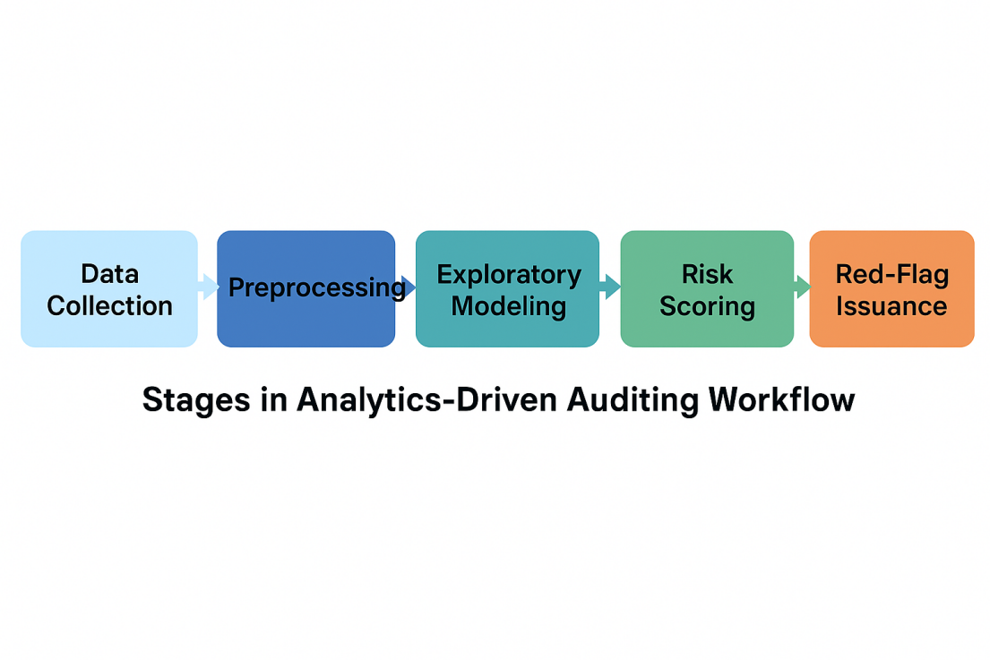
Figure 1. Stages in Analytics-Driven Auditing Workflow

Figure 1 demonstrates that data purification and preparation constitute the most resource-intensive phase in the analytics life-cycle, generally comprising approximately 50% of the overall effort necessary for audit execution. Corporations must devise strategies for adequate resource allocation, automation, and personnel development to guarantee continuous process performance. In addition, incorporating automation in initial phases such as data ingestion and report creation can markedly diminish audit delays, improve operational efficiency and facilitate real-time decision-making. This organized operational sequence upgrades corporate resilience through proactive fraud prevention and ongoing risk monitoring.

2.6. Extraction and Typo-logical Classification of Red-Flag Indicators
Efficient fraud detection relies on promptly recognizing warning signs generally known as red-flag indicators. A classification framework designed to classify indicators based on their intricacy and the traceability of their data sources provides the basis for this classification. The sorting has five principal clusters:

- Transaction irregularities (duplicate transactions or payments executed outside of business hours)
- Behavioral anomalies (recurrent violations of internal controls)
- Structural anomalies (unbalanced ledger accounts or incongruous reconciliations)
- Identify document discrepancies (modified, counterfeit, or replicated invoices)
- Patterns of relational fraud (indications of coordination or synchronized fraudulent activities among entities)

Each cluster is associated with particular analytical techniques.For example, regression models, clustering algorithms or relational network analysis, contingent upon the characteristics and intricacy of the identified patterns. This stratified method expands the precision of model selection and facilitates better-informed audit judgments in data-intensive contexts. Moreover, it equips the prioritizing of audit risks by associating particular red flag signs with specific fraud schemes, ensuring that high-risk situations receive prompt and suitable investigation scrutiny.

2.7. Thematic Synthesis and Validation Protocol
An inductive theme synthesis method following the framework established by Thomas and Harden (2008), was utilized to examine a diverse range of literature. The process was conducted in three separate phases to ensure a thorough and open evaluation.

- Coding the findings: The findings were coded by reading each article line-by-line to extract critical features and topics. This required methodically classifying data points pertaining to audit tool features, alert indicators, implementation challenges and value propositions.

- Formulating descriptive themes: Through iterative comparison analysis, the preliminary codes were consolidated into overarching, descriptive themes. This step included organizing and synthesizing the principal findings of the literature into broad themes.

- Formulating analytical themes: The concluding phase went beyond a mere review of the literature to establish a novel interpretive framework. A conceptual model was developed by recognizing links and patterns among the descriptive themes to demonstrate the strategic importance of data curation, context-specific tool selection, fraud pattern modeling and operational integration in audit environments.

Further evidence added little value when no new subjects come from other sources. To improve interpretative reliability, the codebook was subjected to cross-review and refinement during analytical cycles, ensuring thematic consistency across diverse document types and stakeholder perspectives.

Triangulated Validation Framework: To further validate the findings, a rigorous triangulation framework was used to ensure that the results were evidence-based and representative of real-world complexities. This involved:
- Contrasting academic findings with the industry norms and practices of the Big Four firms;
- Verifying that tool functionality corresponded with publicly accessible documentation;
- Correlating red-flag typologies with real case narratives in forensic accounting reports.
This rigorous triangulation ensured that findings were evidence-based and representative of real-world intricacies.

This systemic framework adds comparison matrices, typological classification, visual mapping and theme synthesis to enable a thorough, multi-dimensional examination of business analytics in audit and fraud detection. The theory aims to provide theoretical depth and practical relevance, allowing academics and practitioners to critically assess the structural design, functional capabilities and contextual use of analytic tools. It features the strategic significance of data curation, context-specific tool selection, fraud pattern simulation and operational integration in audit settings. The model works as an example for the evidence-based practical application of analytics in digitally transformed assurance environments, harmonizing technical innovation with audit integrity and regulatory standards.

3. Results and Discussion
3.1. Analytical Maturity and Fraud Detection Efficacy
The value of business analytics in auditing is strongly impacted because of the advancement of analytical technologies and models. Organizations that progress from fundamental descriptive techniques to advanced prescriptive analytics generally achieve significant accuracy in fraud detection (Lokanan, 2024). Descriptive analytics analyzes key patterns and historical data trends whereas diagnostic analytics assess the underlying causes of anomalies. Predictive analytics provides the anticipation of potential misconduct before its occurrence. While prescriptive analytics uses high level algorithms such as artificial intelligence and machine learning to recommend the best actions in real-time (Pamisetty, 2021).

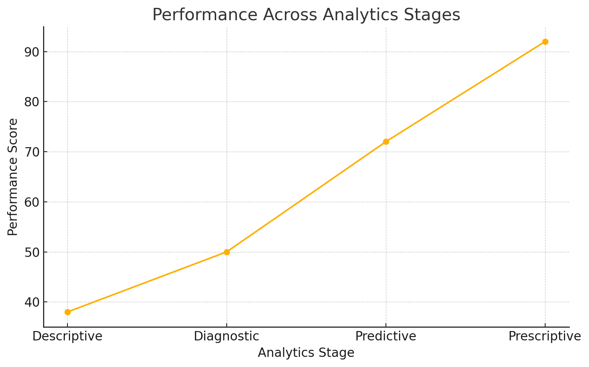
Figure2: Fraud Detection Efficacy Across Analytics Maturity Levels

Figure 2 shows a significant increase in fraud detection success throughout this maturity span. Descriptive analytics generally gains merely 40% anomaly detection because of its passive characteristics (YV & P. K., 2021). Predictive and prescriptive techniques can achieve over 90% accuracy when trained on well-curated data sets and calibrated against fraud taxonomies (Machireddy, 2022). Real-time learning algorithms, natural language processing and relational databases promote predictive accuracy and improve accuracy in audits.

However this advancement requires obstacles. Transitioning to advanced analytics requires infrastructure enhancements, skilled professionals and effective change management practices. Reputed companies in diagnostic or fundamental predictive phases often struggle to justify and validate the financial commitment needed for prescriptive systems (Malempati, 2025). For this reason, analytics maturity put together technological infrastructure with cultural adaptability and long-term strategic orientation.

3.2. Tool-Specific Outcomes and Practical Applications
An in-depth evaluation of prominent audit analytics platforms including ACL, IDEA, Power BI, Tableau, and Python shows specific advantages and disadvantages regarding detection precision, usability and system compatibility. Open-source technologies such as Python and R feature advanced analytical functions provide variation in simulating fraudulent scenarios and demonstrate effectiveness in detecting anomalies (ElDahshan et al., 2024). These techniques are highly applicable to high-risk industries such as finance and e-commerce where illegal financial practices frequently advance beyond the detection capabilities of conventional rule-based approaches (Balogun et al., 2021). In these contexts, unsupervised learning methodologies gain significant importance. In contrast, Tableau and Power BI excel in environments that emphasize visual exploration and efficient presentation of financial data. Although lacking inherent fraud detection capabilities, they provide robust visualization tools that assist auditors in analyzing economic trends and correlations (Thakkar et al., 2025).
Tableau's interactive functionalities facilitate comprehensive financial analysis by enabling users to scrutinize particular levels of financial data. IDEA functions as a pragmatic intermediary that improves access features with adequate analytical profundity. It finds widespread application in governmental and medium-sized enterprises for file consistency verification, fuzzy logic comparisons and regression-based anomaly identification. Despite ACL's limited advanced detection capabilities, its user-friendly interface and standardized reporting format render it a reliable option for structured audit processes (Pinto, 2024). The effectiveness of any platform depends on the entity's technical proficiency, the quality of accessible data and the complexity of the fraud threats under consideration. Institutions with advanced analytical infrastructure can utilize the programmable flexibility and tailored analytical workflows of Python or R. On the other hand, associations devoid of advanced analytics infrastructure may turn to tools like IDEA. (Zavarella, 2024). Selecting the optimal tool requires its alignment with the audit's objectives, the competencies of the audit team and the overall technological landscape (Sewpersadh, 2025). Combining different tools sharpens fraud detection and expedites more informed decision-making in broader circumstances (Javaid, 2024).

3.3. Typological Distribution of Red-Flag Indicators
The identification and categorization of red-flag indicators are essential for fraud detection. A typological matrix classifies indicators into five primary categories: business related abnormalities, aberrant activity profiles, structural inconsistencies, document manipulation and relational fraud patterns (Aivaz et al., 2024).

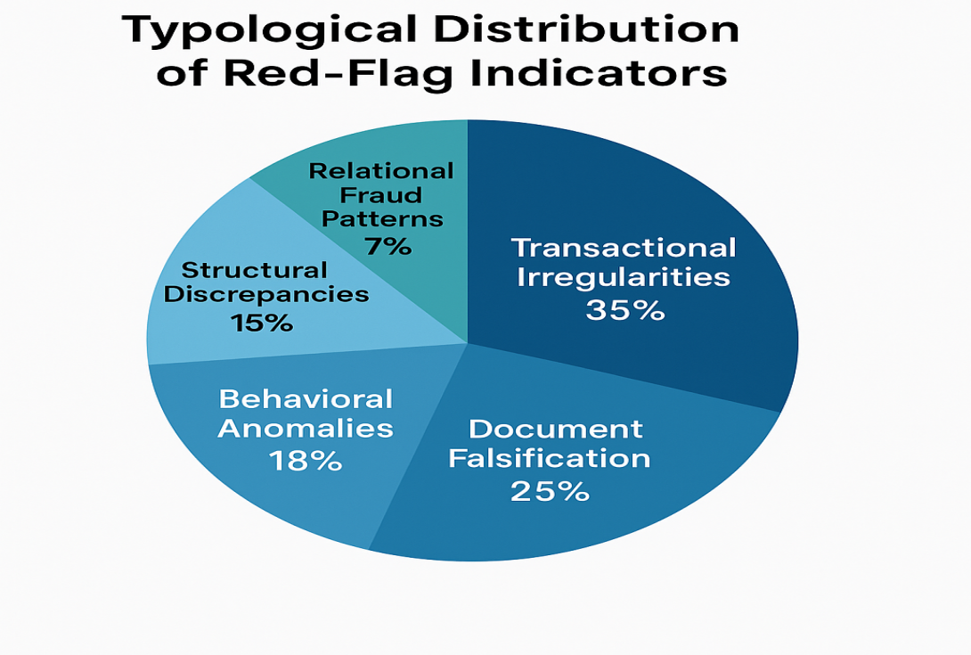

Figure 3 demonstrates that financial irregularities account for the largest share of detected anomalies. These irregularities often occur because of frequent transactions, unusual timing such as rare financial timing or minor differences. These patterns typically show flaws in digital systems or approval workflows. Document manipulation is also widespread and may consist of fake invoices, duplicate records or changes made without approval. (Nogueira et al., 2025). These incidents show systemic vulnerabilities in invoice authorization and documentation integrity.
Unusual patterns in business operations are another key category frequently associated with sudden changes in employee conduct, irregular access patterns or overt resistance to oversight and internal audits (Douglas, 2024). These signs may be considered early indicators of hidden misconduct or deceptive alliance. Structural discrepancies come from inconsistencies across financial statements, business units or reporting structures (Qatawneh, 2024). These discrepancies often point to isolated internal control systems and gaps in governance.Less prevalent relational fraud is considerably more elusive and requires advanced techniques for accurate identification (Hilal et al., 2022). For example, these may include hidden plans such as bid-rigging or collusive networks which require graph-based analytics and cross-entity tracking to detect. As frauds normally bypass detection rules, advanced analytical models and pattern recognition clustering are essential for identification (Popoola, 2023).
The impact on auditing methods is quite significant. Firms must have a multi-tiered red-flag detection system so that it supports dynamic monitoring of financial operations (Adejumo & Ogburie, 2025). Secondly, real-time analytics that captures evolving financial patterns and contextual shifts should replace conventional reactive models. Moreover, practitioners must acknowledge that numerous fraud signs do not exist independently. Intersecting signals among categories may increase risk and demand more comprehensive diagnostic models. Adopting machine learning classifiers augmented with domain-specific information improves the sensitivity and specificity of red-flag detection (Baeyaert, 2025). This connection can foster the development of preventative measures by diminishing exposure to undiscovered fraud and enhancing the integrity of financial systems.

3.4. Sectoral and Institutional Distinction in Analytical Application
The practical implementation of audit analytics significantly differs among sectors which is influenced by regulatory rigour, risk exposure, technological capability and organizational priorities (Bello et al., 2024). Among highly regulated sectors such as finance, healthcare and telecommunications, adoption levels are generally more advanced. These sectors face rigorous compliance mandates and complex operating frameworks which demand the implementation of real-time monitoring systems, predictive fraud detection algorithms and integrated enterprise platforms(Sutisna, 2025). In these contexts, analytics continually simplify preventive measures and post-incident analyses.

In comparison adoption remains limited in the low resources industries. Manufacturing, retail and small to medium-sized firms often operate under limited aid, inadequate IT infrastructures and weak integrated data systems(Akter, 2025). As a result small firms are heavily dependent on basic visualization software or easily implementable commercial technologies. Despite being user-friendly, these solutions frequently lack the analytical expertise necessary for prompt fraud detection, resulting in delayed and reactive responses (Ayodeji, 2024).

The public sector alongside non-profit institutions presents a distinct trajectory in the integration of analytics.Despite limited funding, these non-commercial entities remain significantly susceptible to procurement irregularities, misappropriation of funds and misuse of donor-restricted assets (Pizzini & Sterin, 2025). Although digital transformation has enhanced data accessibility in numerous instances, discrepancies in execution remain. Analytics adoption in these contexts demands customized frameworks that respond to low technical literacy, operational fragmentation and rigorous compliance standards (Alex-Omiogbemi et al., 2024).

The maturity of analytics across sectors cannot be attributed solely to the availability of technology. Institutional readiness, data governance culture and the alignment of analytical strategies with business objectives collectively shape the maturity of analytics assimilation (Solano & Cruz, 2024). Establishing high-performing audit analytics solutions demands a holistic grasp of workflow limitations, structural environments and contextual industry risks.

3.5. Organizational Readiness and Comparative Capability Gaps
Successful application of audit analytics completely depends on institutional readiness and adaptability.The comparative matrix (Table 3) shows that deficiencies in audit maturity are primarily influenced by the availability of tools as well as by personnel competencies, system integration difficulties and reluctance to change.
Comparative Table: Traditional vs. Analytics-Driven Auditing
Parameter | Traditional Auditing | Analytics-Driven Auditing
Tool Adaptability | Low. | High (Wagener et al., 2025).
Staff Proficiency | High in accounting. | Hybrid (accounting + data) (Oliveira & Ribeiro, 2022).
Data Infrastructure | Manual/Legacy | Automated/Data Lake.
Fraud Detection Speed | Delayed. | Real-time (Naoufal, 2024).
Scalability | Limited. | High (Oko-Odion & Udoh, 2024).

Table 3: Comparative Organizational Readiness Across Audit Models
Conventional audits prioritize accounting proficiency yet exhibit a deficiency in data literacy. On the other hand, analytics-driven solutions require a combination of expertise in finance and data science. Organizations without focused recruitment or training may implement tools but struggle to extract meaningful diagnostic insights.Old infrastructure presents an additional limitation. Numerous companies utilize isolated, antiquated systems that compromise data integrity and restrict anomaly detection. Integrated platforms featuring real-time data streams augment continuous auditing and fraud simulation capabilities.Scalability further distinguishes models. Manual audits operate within the bounds of human capacity whereas analytics-driven systems offer modularity and scalability. Following implementation, expansion across organizational units incurs minimal additional resource investment.

3.6. Workflow Efficacy and Governance Alignment
Integrating analytics into the audit phases accelerates procedural efficiency and strategic responsiveness. The audit process has five interconnected phases such as data collecting, data preparation, modelling, risk assessment and red-flag generation (Ruhnke, 2023). Instead of acting as a strict linear progression, these stages function inside a flexible feedback loop where insights from subsequent stages enhance and improve earlier processes.
Data preparation remains the most demanding cycle in terms of time and resource allocation, often representing nearly half of the overall effort. This phase involves multiple tasks, including data cleaning, normalization, record consolidation and classification and each of the steps significantly influences the accuracy and performance of analytical models (Joshi & Patel, 2021). To enhance these operations, many organizations have begun to implement automation technologies such as robotic process automation, extract-transform-load pipelines and advanced data wrangling systems (Vajpayee, 2023). These solutions minimize manual effort while increasing data quality and consistency.
The risk scoring stage plays a vital role in prioritizing audit activities. Anomalies are evaluated based on parameters like severity, frequency and potential financial impact. The resulting risk scores guide auditors in directing resources toward high-priority cases. Incidents that exceed defined thresholds are escalated for detailed forensic investigation or submitted to senior management for immediate review and intervention (Henriques, 2024).
Effective governance alignment ensures that analytical outputs are translated into actionable institutional improvements (Carreño, 2024). Patterns identified in the red-flag phase are used to inform upstream decisions and policy revisions. For example, consistent indicators of procurement-related irregularities may prompt changes in vendor selection protocols, contract approval workflows or oversight mechanisms (Sarkola, 2023. By integrating governance structures within the analytics framework, move from reactive detection to anticipatory risk mitigation and system-wide accountability.

3.7. Validation and Forward Pathways
Triangulation across academic, professional and forensic fields validates that analytical tools improve audit results. Cross-referencing with material from Big Four firms, forensic audit reports and publicly available case analyses provided validation. The previously described performance-enhancing properties of analytics offer crucial context to understand the subsequent institutional and technical hurdles.However the trajectory ahead requires confronting enduring constraints. These cover the following areas:
- Data interoperability: Improving compatibility across platforms (Mai, 2022).
- Training ecosystems: Developing auditor competencies in SQL, Python, and AI interpretability (George, 2022).
- Regulatory clarity: Establishing worldwide standards for algorithmic audits and understandable artificial intelligence in assurance (Akula & Garibay, 2021).
Collaboration across disciplines is crucial. Audit teams must collaborate with IT, data science, legal and compliance departments to create comprehensive fraud detection solutions. Furthermore, real-time simulation environments, or "fraud sandboxes" may facilitate the testing of algorithmic models without legal or ethical dilemmas. Implementing structured feedback mechanisms between auditors and model developers can enhance model validity and mitigate bias over time.

4. Conclusion and Policy Recommendations
4.1. Conclusion
This research examines the impact of business analytics on audit and fraud detection in the different institutional contexts. Data-driven methods help businesses to shift from conventional retrospective practices to real-time, predictive and risk-oriented auditing. This study's analytical maturity model shows the evolution from fundamental descriptive tools to sophisticated prescriptive systems that showcasing substantial improvements in anomaly detection accuracy and fraud prevention results. The assessment of tool-specific implementations depicts the complex trade-offs among usability, deception modelling efficacy, visualization features and institutional preparedness. The structural analysis of red-flag indicators reinforces the necessity of classifying fraud symptoms based on their data complexity and contextual traceability. Sectoral analysis indicates significant disparities in adoption, shaped by regulatory precision, technological proficiency and organizational agendas. Comparative frameworks demonstrate that analytics-driven audits provide expanded scope, immediate reactivity and risk traceability that are establishing them as essential tools in contemporary assurance ecosystems. Despite these edges, enduring issues persist. These illustrate infrastructure fragmentation expertise deficiencies among audit professionals and ethical concerns about algorithmic bias and transparency.
This research enhances audit theory by showing how business analytics may convert conventional audits into real-time, risk-oriented systems. It contributes to the literature by systematically compiling and comparing audit tools by categorizing red-flag signs and examining sector-specific issues. It also provides a coherent framework that connects analytics, governance and fraud detection. These contributions assist scholars and professionals to understand the application of audit analytics in practical contexts and facilitate further inquiries into smart auditing. The findings show the necessity for standardized algorithmic audit processes, investment in updated digital infrastructure, interdisciplinary training in analytical skills and the creation of fraud simulation settings. Moreover synchronizing analytics implementation with industry-specific governance frameworks and integrating audit insights into institutional decision-making processes are crucial for improving the effectiveness of data-driven assurance procedures in commercial and governmental contexts.
4.2. Policy Recommendations
Policymakers, regulators and leaders should implement the following strategic initiatives to execute findings from analytics-enhanced auditing. Standardization of algorithmic audit protocols is essential. Regulatory authorities ought to formulate internationally accepted standards for artificial intelligence and machine learning in auditing. These frameworks must prioritize a transparent audit process to ensure adherence to ethical and legal requirements. Investment in digital audit infrastructure is also necessary. Institutions should prioritize upgrading legacy systems to enable seamless integration of analytical tools. Policies that endorse cloud-based audit platforms, real-time data streams and centralized data governance can reinforce operational efficiency. Development of competence and interdisciplinary training must be reinforced. Making a new auditor competency framework is essential in addressing the complexities of modern audit practices to bring skills in SQL, Python, inferential statistics and data visualization. Governments and professional organizations can significantly contribute by financing certificates, workshops and university-level programs in audit analytics.

Requiring fraud simulation environments is another key initiative. The inception of "fraud sandboxes" can provide secure and regulated settings to evaluate the effectiveness and equity of fraud detection algorithms. These simulation models can improve innovation and regulatory scrutiny while reducing unexpected legal issues for institutions. Implementation frameworks specific to sectors are also required. To maintain relevance and impact, auditing analytics must align with sector-specific risk exposures, organizational dimensions and compliance structures. Public sector entities, non-profit organizations and small to medium-sized enterprises need streamlined frameworks featuring modular, scalable modules with simulation-constrained resources and staffing capacities. Integrating governance and ongoing feedback mechanisms is crucial. Organizations should integrate analytical results into formal governance structures to ensure identified anomalies impact upstream policy decisions. Implementing systematic feedback mechanisms across audit teams, IT departments and executive leadership helps improve model precision and organizational learning. By aligning these policy directives with the advancing technological landscape, stakeholders can enhance audit credibility, promote fraud resistance and assist data-driven public accountability in business and public contexts.

References (in APA 7):
Adejumo, A., & Ogburie, C. (2025). Financial statement manipulation: Ethical and regulatory perspectives. GSC Advanced Research and Reviews, 22(03), 252-264.
Adepoju, A. H., Austin-Gabriel, B. L. E. S. S. I. N. G., Hamza, O. L. A. D. I. M. E. J. I., & Collins, A. N. U. O. L. U. W. A. P. O. (2022). Advancing monitoring and alert systems: A proactive approach to improving reliability in complex data ecosystems. IRE Journals, 5(11), 281-282.
Aivaz, K. A., Florea, I. O., & Munteanu, I. (2024). Economic Fraud and Associated Risks: An Integrated Bibliometric Analysis Approach. Risks, 12(5), 74.
Akter, M. (2025). Enhancing SME Competitiveness: the Role of Business Intelligence in Data-Driven Decision-Making.
Akula, R., & Garibay, I. (2021). Audit and assurance of AI algorithms: a framework to ensure ethical algorithmic practices in artificial intelligence. arXiv preprint arXiv:2107.14046.
Akula, R., & Garibay, I. (2021). Audit and assurance of AI algorithms: a framework to ensure ethical algorithmic practices in artificial intelligence. arXiv preprint arXiv:2107.14046.
Alex-Omiogbemi, A. A., Sule, A. K., Omowole, B. M., & Owoade, S. J. (2024). Conceptual framework for advancing regulatory compliance and risk management in emerging markets through digital innovation.
Ayodeji, I. A. (2024). Fraud Detection and Prevention in the Nigerian Financial Industry (Doctoral dissertation, Walden University).
Baeyaert, J. (2025). Harmonizing creativity and ethics in AI systems. AI and Ethics, 1-21.
Balogun, E. D., Ogunsola, K. O., & Samuel, A. D. E. B. A. N. J. I. (2021). A risk intelligence framework for detecting and preventing financial fraud in digital marketplaces. ICONIC RESEARCH AND ENGINEERING JOURNALS, 4(08), 134-149.
Bello, H. O., Ige, A. B., & Ameyaw, M. N. (2024). Adaptive machine learning models: concepts for real-time financial fraud prevention in dynamic environments. World Journal of Advanced Engineering Technology and Sciences, 12(02), 021-034.
Carreño, A. M. (2024). Strategic Alignment in Program Management: A Framework for Sustainable Business Transformation. Institute for Change Leadership and Business Transformation. https://doi. org/10.5281/zenodo, 13922003.
Chowdhury, Rakibul Hasan, and A. A. Masum. "Utilizing business analytics to combat financial fraud and enhance economic integrity." International Journal of Science and Research Archive 14.1 (2025): 134-145.
Darvish, K., Skreta, M., Zhao, Y., Yoshikawa, N., Som, S., Bogdanovic, M., ... & Shkurti, F. (2025). ORGANA: a robotic assistant for automated chemistry experimentation and characterization. Matter, 8(2).
Darwin, K. (2024). Strengthening Public and Private Accountability through Digital Forensic Accounting. Sinergi International Journal of Accounting and Taxation, 2(4), 225-238.
Darwish, D. (Ed.). (2024). Emerging trends in cloud computing analytics, scalability, and service models.
Douglas, F. (2024). Can Small Businesses Deter Fraud? A Qualitative Examination of Preventive and Detective Internal Control Strategies (Doctoral dissertation, National University).
Ebirim, G. U., Unigwe, I. F., Oshioste, E. E., Ndubuisi, N. L., Odonkor, B., & Asuzu, O. F. (2024). Innovations in accounting and auditing: A comprehensive review of current trends and their impact on US businesses. Int. J. Sci. Res, 11, 965-974.
ElDahshan, K. A., Abutaleb, G. E., Elemary, B. R., Ebeid, E. A., & AlHabshy, A. A. (2024). An optimized intelligent open-source MLaaS framework for user-friendly clustering and anomaly detection. The Journal of Supercomputing, 80(18), 26658-26684.
Elumilade, O. O., Ogundeji, I. A., Ozoemenam, G. O. D. W. I. N., Omokhoa, H. E., & Omowole, B. M. (2024). Advancing audit efficiency through statistical sampling and compliance best practices in financial reporting. IRE Journals, 7(9), 434-437.
Faccia, A., & Petratos, P. (2024, May). Big Data Applications in Accounting Information Systems. In Proceedings of the 2024 9th International Conference on Big Data and Computing (pp. 1-7).
Fernandes Jr, G., Rodrigues, J. J., Carvalho, L. F., Al-Muhtadi, J. F., & Proença Jr, M. L. (2019). A comprehensive survey on network anomaly detection. Telecommunication Systems, 70(3), 447-489.
Fiolleau, K., MacTavish, C., Osecki, E., & Thorne, L. (2024). An Exploration of Technological Innovations in the Audit Industry: Disruption Theory Applied to a Regulated Industry. Accounting Perspectives, 23(3), 403-445.
George, J. (2022). Optimizing hybrid and multi-cloud architectures for real-time data streaming and analytics: Strategies for scalability and integration. World Journal of Advanced Engineering Technology and Sciences, 7(1), 10-30574.
Hamdam, A., Jusoh, R., Yahya, Y., Abdul Jalil, A., & Zainal Abidin, N. H. (2022). Auditor judgment and decision-making in big data environment: a proposed research framework. Accounting Research Journal, 35(1), 55-70.
Hassan, A., Salleh, N., Ismail, M. N., Ahmad, M. N., & Hussin, A. R. C. (2023). Empirical evaluation of continuous auditing system use: a systematic review. International Journal of Electrical and Computer Engineering, 13(1), 796.
Henriques, J. P. M. (2024). Audit Compliance and Forensics Frameworks for Improved Critical Infrastructure Protection (Doctoral dissertation, Universidade de Coimbra).
Hezam, Y. A., Anthonysamy, L., & Suppiah, S. D. K. (2023). Big data analytics and auditing: A review and synthesis of literature. Emerging Science Journal, 7(2), 629-642.
Hilal, W., Gadsden, S. A., & Yawney, J. (2022). Financial fraud: a review of anomaly detection techniques and recent advances. Expert systems With applications, 193, 116429.
Ilori, O., Nwosu, N. T., & Naiho, H. N. N. (2024). Advanced data analytics in internal audits: A conceptual framework for comprehensive risk assessment and fraud detection. Finance & Accounting Research Journal, 6(6), 931-952.
Javaid, H. A. (2024). Improving fraud detection and risk assessment in financial service using predictive analytics and data mining. Integrated Journal of Science and Technology, 1(3).
Johnson-Rokosu, S. F., & Enobi, A. (2025). Behavioral Analytics and Forensic Accounting: Understanding the Human Element in Fraud.
Joshi, A. P., & Patel, B. V. (2021). Data preprocessing: the techniques for preparing clean and quality data for data analytics process. Orient. J. Comput. Sci. Technol, 13(0203), 78-81.
Kothandapani, H. P. (2025). AI-Driven Regulatory Compliance: Transforming Financial Oversight through Large Language Models and Automation. Emerging Science Research, 12-24.
Landers, R. N., & Behrend, T. S. (2023). Auditing the AI auditors: A framework for evaluating fairness and bias in high stakes AI predictive models. American Psychologist, 78(1), 36.
Lokanan, M. (2024). Harnessing Exploratory Data Analysis for Robust Financial Fraud Detection and Model Enhancement.
Machireddy, J. R. (2022). Integrating predictive modeling with policy interventions to address fraud, waste, and abuse (fwa) in us healthcare systems. Advances in Computational Systems, Algorithms, and Emerging Technologies, 7(1), 35-65.
Mai, L. P. (2022). Changes in competencies, capabilities, and decision-making in the accounting profession as a result of information digitalization and big data analytics/artificial intelligence.
Malempati, M. (2025). The Intelligent Ledger: Harnessing Artificial Intelligence, Big Data, and Cloud Power to Revolutionize Finance, Credit, and Security. Deep Science Publishing.
Naoufal, G. (2024). Continuous auditing/continuous monitoring. In Continuous Auditing with AI in the Public Sector (pp. 143-162). CRC Press.
Nogueira, D. M., Simões, M., Ferreira, C., Ribeiro, R. P., Martínez-Rego, D., Cai, A., & Gama, J. (2025). Survey on Detection of Fraudulent Documents. Authorea Preprints.
Nouri, Z. (2024). Financial Audit Using Data Analytics (Master's thesis, Universidade NOVA de Lisboa (Portugal)).
Oko-Odion, C., & Udoh, O. R. (2024). Leveraging technology in internal audit processes for streamlined management and risk oversight.
Oliveira, J., & Ribeiro, P. J. (2022). Technological developments and new hybrid roles in accounting and finance. In The Routledge Handbook of Accounting Information Systems (pp. 156-170). Routledge.
Pamisetty, V. (2021). Integrating Predictive Analytics and IT Infrastructure for Advanced Government Financial Management and Fraud Detection. Available at SSRN 5275676.
Pamisetty, V. (2021). Integrating Predictive Analytics and IT Infrastructure for Advanced Government Financial Management and Fraud Detection. Available at SSRN 5275676.
Panchapakesan, A., Anandaram, H., Sridevi, L., Sathish, K. M., Dhivya, P., Parameswari, S., ... & Kapadia, H. (2025). Enhancing Audit Effectiveness Through Strategic Data Analytics. In Machine Learning and Modeling Techniques in Financial Data Science (pp. 231-252). IGI Global Scientific Publishing.
Pinto, A. R. O. (2024). A Framework for Leveraging it Audit Using Artificial Intelligence (Master's thesis, Universidade NOVA de Lisboa (Portugal)).
Pinto, A. R. O. (2024). A Framework for Leveraging it Audit Using Artificial Intelligence (Master's thesis, Universidade NOVA de Lisboa (Portugal)).
Pizzini, M., & Sterin, M. (2025). The relation between cash reserves, governance, and donations in nonprofit organizations. Journal of Accounting, Auditing & Finance, 40(1), 139-164.
Popoola, N. T. (2023). Big data-driven financial fraud detection and anomaly detection systems for regulatory compliance and market stability. Int. J. Comput. Appl. Technol. Res, 12(09), 32-46.
Prosper, J. (2025). Data Conversion Failures and Their Influence on Fraud Detection and Audit Accuracy in Medicare and Medicaid.
Qatawneh, A. M. (2024). The role of artificial intelligence in auditing and fraud detection in accounting information systems: moderating role of natural language processing. International Journal of Organizational Analysis.
Ruhnke, K. (2023). Empirical research frameworks in a changing world: The case of audit data analytics. Journal of International Accounting, Auditing and Taxation, 51, 100545.
Rumasukun, M. R. (2024). Developing auditor competencies through continuous training and education. Golden Ratio of Auditing Research, 4(1), 14-23.
Sarkola, M. (2023). Developing global system-based indirect purchasing in the case company.
Sewpersadh, N. S. (2025). Adaptive structural audit processes as shaped by emerging technologies. International Journal of Accounting Information Systems, 56, 100735.
Sewpersadh, N. S. (2025). Adaptive structural audit processes as shaped by emerging technologies. International Journal of Accounting Information Systems, 56, 100735.
Solano, M. C., & Cruz, J. C. (2024). Integrating analytics in enterprise systems: A systematic literature review of impacts and innovations. Administrative sciences, 14(7), 138.
Sutisna, E. (2025). Evaluating Security Risks and the Impact of Analytic Technology on the Audit Process. Advances in Managerial Auditing Research, 3(1), 30-43.
Syam, M., Djaddang, S., & Roziq, M. (2025). The Digital Transformation of Auditing: Navigating the Challenges and Opportunities. Syahril and., Hasnawati and Roziq, Mohammad and., Harnovinsah.
Thakkar, H., Fanuel, G. C., Datta, S., Bhadra, P., & Dabhade, S. B. (2025). Optimizing Internal Audit Practices for Combatting Occupational Fraud: A Study of Data Analytic Tool Integration in Zimbabwean Listed Companies. International Research Journal of Multidisciplinary Scope, 6(1), 22-36.
Thakkar, H., Fanuel, G. C., Datta, S., Bhadra, P., & Dabhade, S. B. (2025). Optimizing Internal Audit Practices for Combatting Occupational Fraud: A Study of Data Analytic Tool Integration in Zimbabwean Listed Companies. International Research Journal of Multidisciplinary Scope, 6(1), 22-36.
Usul, H., & Alpay, B. Y. (2025). Digital Transformation in Internal Audit: Paradigm Shifts, Emerging Risks, and Strategic Resilience. European Journal of Digital Economy Research, 6(1), 23-36.
Vajpayee, A. (2023). The Role of Machine Learning in Automated Data Pipelines and Warehousing: Enhancing Data Integration, Transformation, and Analytics. ESP Journal of Engineering & Technology Advancements, 3(3), 84-96.
Vesty, G., Kokshagina, O., Jansson, M., Cheong, F., & Butler-Henderson, K. (2023). Accounting, valuing and investing in health care: dealing with outdated accounting models. Meditari Accountancy Research, 31(1), 52-77.
Wagener, M., Eulerich, M., & Bonrath, A. (2025). From Pen-and-Paper to Technology-Driven Analytics: Technology Usage in Internal Auditing. Journal of Information Systems, 1-28.
YV, P. K. (2021). Simple and effective descriptive analysis of missing data anomalies in smart home energy consumption readings. Journal of Energy Systems, 5(3), 199-220.
Zavarella, L. (2024). Extending Power BI with Python and R: Perform advanced analysis using the power of analytical languages. Packt Publishing Ltd.

